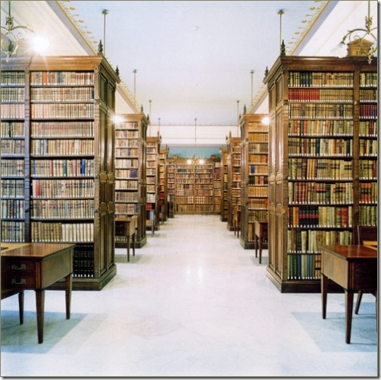

**SUBMITTED BY**

**AYESHA TASNEEM**

**SUBMITTED TO**

**MAM SANA**

**ACKNOWLEDGEMENT**

The satisfaction that accompanies that the successfulcompletion of any task would be incomplete without themention of people whose ceaseless cooperation made it

possible, whose constant guidance and encouragementcrown all efforts with success.

We are grateful to our project guide mam Sana for theguidance, inspiration and constructive suggestions that helpful us in the preparation of this project.she has been a constant source of inspiration and motivation for hard work.she has been very co-operative throughout this project work. Through this column, it would be our utmost pleasure to express our warm thanks to him for her encouragement, co-operation and consent without which we mightn’t be able to accomplish this project.I also thank my parents who have helped in successful completion of the project.

**AYESHA TASNEEM**

FINAL APPROVAL

It is to certify that AYESHA TASNEEM is bonafide student of ASKARIA COLLEGE ,xii year ,section G5B,roll no _______________,session 2010__2012.

She has successfully completed her project titled under "LIBRARY MANAGEMENT SYSTEM''.

Signature of supervisor

____________________

**TABLE OF CONTENTS**

* ACKNOWLEDGEMENT
* SCOPE OF THE PROJECT
* INTRODUCTION
* PROBLEM DEFINITION
* MAIN OBJECTIVE
* EXISTING SYSTEM
* PROPOSED SYSTEM
* ADVANTAGES OF PROPOSED SYSTEM
* DISADVANTAGES OF PROPOSED SYSTEM
* SYSTEM DESIGN
* BASIC OBJECTS OF A DATABASE

**SCOPE OF PROJECT**

The different areas where we can use this application are:

The different areas where we can use this applicationare : • Any education institute can make use of it for providing information about author, content of the available books. • It can be used in offices and modifications can be easily done according to requirements

Any educati ationonal institute can make use of it for providing information about author,content of the available books.

It can be used in offices and modifications can be easily done according to requirements.

Many book shops can make use of this

Schools can also make use of this for keeping record of any thing and they can also make changes according to.This application can be easily implemented under various situations. We can add new features as and when we require. Reusability is possible as and when require in this application.

**INTRODUCTION**

The national library,in pakistan is widely considered to be one of the world,s greatest library of human history and culture.Its permanent collection,numbering some eight million works,is amongst the finest ,most comprehensive,and largest in existence and originate from all continents,illustrating and documenting the story of human culture from its beginings to the present.

The national library was established in1993,largely based on the collection of the physicians and scientists.it exchanges government documents with USA . Pakistan

National bibliography with other national libraries of the world serves as depositry for ASIAN DEVELOPMENT BANK publications and provides information and photocopy service. It is the member of the International Federation Of Library Associations. Iserves not only the top informations but a coordinating force for all libraries. Over a short apan of two years the library has acquired numerous collections through purchases, copy right deposits

* Books-130,000 volumes
* Manuscripts_555 titles
* Microfilms_45 reels
* Microfitches-48000 cards
* Magazines-845 titles
* Newspapers-135 titles

The library strives to develop significant collection of human knowledge, comprehensive collection of national literary heritsage and deliver excellent Library services for promotion of knowledge based society in Pakistan . The Library is responsible for National bibliographic control and preserves the literary heritage of the country for the use of present as well as future generations.

These collections include 40100 pakistani publications received under the provisions of the copyright law . special collections include rare hand written manuscripts in persian language relating to history oof Kashmir and first copy of KULYATE MEER pu

Blished in 1811 .the library has also acquired copies of about 30 phd dissertations written in American universaties.

The building was constructed at a plot measuring 500 ft,the national library has covered an area of 168800 sq ft.it is a centrally air conditioned building with a capacity to accommodate 1 million volumes ,500 general reader seats, work area for staff,auditorium and other services.

The national library of pakistan serves as cultural center of the capital. Library is intended to be the reference library for all purposes,a working place for scholars ,postgraduate students of social sciences and humanities and repository of national published literature for future historians. But one problem is that the library uses files to save al necessary information.

**PROBLEM DEFINITION**

The existing system used in this library is file system,which has caused many problems. Following are the disadvantages of traditional file approach.

The data maintained in the file is easily accessible and therefore not secure .The customer transaction file has details about the total available balance of all customer .A customer wants information about his account balance.In a file system it is difficult to give the customer access to only his data in the file .Thus enforcing security constraints for the entire file

or for certain data items are difficult .

Often the same information is duplicated in two or more files.This duplication of data leads to higher storage and access cost.In addition it may lead to data inconsistency.Assume that the same data is repeated in two or more files.If change is made to data in one file,it is required that the change be made to the data in the other file as well.If this is not done,it will lead to error during access to data.

Data isolation means that all the related data is not available in one file.Generally,the data is scattered in various files,and the files may be in different formats,therefore writing new application programs to retrieve the appropriate data is difficult.

**MAIN OBJECTIVE**

My project on “Library Management” deals with the transaction happenings in Library in an organization/institute.

This project will be proved easier, as more of the tasks obtained are managed by a mouse click. The final reports and other facilities and calculations are calculated and updated automatically. Throughout the project the focus has been on presenting information and comments in an easy and intelligible manner. The project is very useful for those who want to know about Library Management System. After we have completed the project we are sure the problems in the existing system would overcome. The “LIBRARY MANAGEMENT SYSTEM” process made computerized to reduce human errors and to increase the efficiency. The main focus of this project is to lessen human efforts. The maintenance of the records is made efficient, as all the records are stored in the ACCESS database, through which data can be retrieved easily. The navigation control is provided in all the forms to navigate through the large amount of records. If the numbers of records are very large then user has to just type in the search string and user gets the results immediately. The editing is also made simpler. The user has to just type in the required field and press the update button to update the desired field.

EXISTING SYSTEM

The existing system used in the library is manual system which has caused many problems. Following are the problems caused due to manual system used in the library.

* Fast report generation is not possible.
* Tracing a book is difficult.
* Information about issue/return of the books are not properly mantaine.
* Greater data integrity and independance from applications programs
* Increased data redundancy
* Increased data inconsistency
* Decreased flexibility
* Decreased data security
* Increased data entry, storage, and retrieval costs
* In Facilitated development of new applications program
* It means all of the information is not together.
* The information cannot be portable.
* The information is difficult to access at any time.
* It's more difficult retrievable.
* Many people cannot access the same information at the same time..
* Stock maintenance.has become difficult.
* Transaction entry is not possible
* It provides "in accurate and un efficient" service to members.
* Increased the workload of employee.
* lower retrieval of information about the desired book.
* Provide improper monitoring increased paper work and provides no data security.
* All details will be unavailable if needed in emergency.

**PROPOSED SYSTEM**

**.** Proposed system is an automated Library Management System. Through our software user can add books, search books, renewal, update information, edit information, and return books in quick time. The proposed system which is data base management system will solve many problems.following are the problems solved by data base management system in library management system

User friendly interface.  
 Fast access to database.  
Less error.  
 More Storage Capacity.  
 Search facility.  
 Look and Feel Environment.  
 Quick transaction.  
 Reduced data redundancy.

Reduced updating errors and increased consistency.

**Advantage of proposed system**

* Greater data integrity and independance from applications programs
* Improved data access to users through use of host and query languages
* Improved data security
* Reduced data entry, storage, and retrieval costs
* Facilitated development of new applications program
* Reduced data redundancy i.e. no unnecessarily duplicated data
* All attributes will be independent
* Database structure is flexible i.e. it will be possible to add new data and entities without a wholesale reorganisation of the database structure.
* Data is consistent throughout the database
* Complex queries required by the user should be possible
* It means all of the information is together.
* The information can be portable if on a laptop.
* The information is easy to access at any time.
* It's more easily retrievable.
* Many people can access the same database at the same time.
* Improved data security.
* Reduced data entry, storage, and retrieval costs.
* Stock maintenance.
* . Transaction entry
* 1 It provides "better and efficient" service to members.
* . Reduce the workload of employee.
* . Faster retrieval of information about the desired book.
* . Provide facility for proper monitoring reduce paper work and provide data security.
* . All details will be available on a click.
* It provides "better and efficient" service to members.
* It reduces the work load of employees.
* Faster retrieval of the information about the desired books is available.
* It provides facilities for proper monitoring.
* It reduces paper work and provides data security.
* All details will be available on a click.

**Disadvantages of proposed system**

* Database systems are complex, difficult, and time-consuming to design
* Substantial hardware and software start-up costs
* Damage to database affects virtually all applications programs
* Extensive conversion costs in moving form a file-based system to a database system
* Initial training required for all programmers and users

**SYSTEM DESIGN**

**ENTITY RELATIONSHIP DIAGRAM**

An entity relationship diagram is a diagrammatic way of representing a relationship between the entities in a data base.to show the relationship between the two entities ,both the relationship type and the name of the relationship need to be specified.

BASIC OBJECTS OF DATABASE

**MEMBER**

**ISSUED**

**BY**

**PUBLISHER**

**PUBLISHED BY**

**BOOK**

**Tables**

A database table is similar in appearance to a spreadsheet, in that data is stored in rows and columns. As a result, it is usually quite easy to import a spreadsheet into a database table. The main difference between storing your data in a spreadsheet and storing it in a database is in how the data is organized.

To get the most flexibility out of a database, the data needs to be organized into tables so that redundancies don't occur. For example, if you're storing information about employees, each employee should only need to be entered once in a table that is set up just to hold employee data. Data about products will be stored in its own table, and data about branch offices will be stored in another table. This process is called *normalization*.

Each row in a table is referred to as a record. Records are where the individual pieces of information are stored. Each record consists of one or more fields. Fields correspond to the columns in the table. For example, you might have a table named "Employees" where each record (row) contains information about a different employee, and each field (column) contains a different type of information, such as first name, last name, address, and so on. Fields must be designated as a certain data type, whether it's text, date or time, number, or some other type.

Another way to describe records and fields is to visualize a library's old-style card catalog. Each card in the cabinet corresponds to a *record* in the database. Each piece of information on an individual card (author, title, and so on) corresponds to a *field* in the database.

There are three tables in this project of library management system. Their fields and data types are as follows

* BOOK
* MEMBER
* PUBLISHER

**BOOK**

|  |  |
| --- | --- |
| **FIELD NAME** | **DATA TYPE** |
| Book id | Number |
| Type | Text |
| Title | Text |
| Price | Number |
| Date published | Text |

**MEMBER**

|  |  |
| --- | --- |
| **FIELD NAME** | **DATA TYPE** |
| Member id | Number |
| **N**ame | Text |
| Dob | Text |
| Address | Text |
| Card no | Number |
| Phone num | Number |
| Fines | Yes\No |

**PUBLISHER**

|  |  |
| --- | --- |
| **FIELD NAME** | **DATA TYPE** |
| ID | Number |
| Name | Text |
| Address | Text |

**Forms**

Forms are sometimes referred to as "data entry screens." They are the interfaces you use to work with your data, and they often contain command buttons that perform various commands. You can create a database without using forms by simply editing your data in the table datasheets. However, most database users prefer to use forms for viewing, entering, and editing data in the tables.

Forms provide an easy-to-use format for working with the data, and you can also add functional elements, such as command buttons, to them. You can program the buttons to determine which data appears on the form, open other forms or reports, or perform a variety of other tasks. For example, you might have a form named "Customer Form" in which you work with customer data. The customer form might have a button which opens an order form where you can enter a new order for that customer.

Forms also allow you to control how other users interact with the data in the database. For example, you can create a form that shows only certain fields and allows only certain operations to be performed. This helps protect data and to ensure that the data is entered properly

FORM OF BOOKS

. 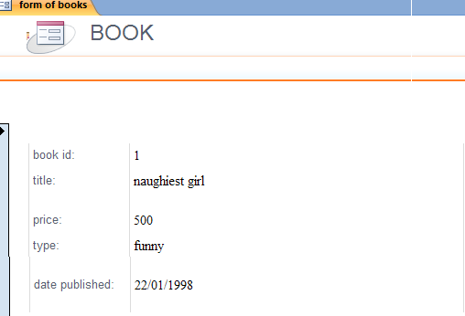

FORM OF PUBLISHER

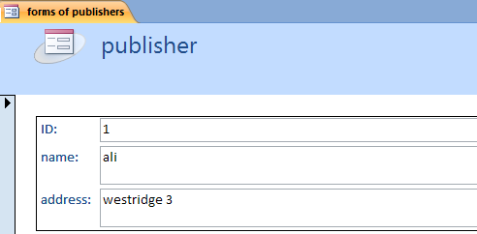

FORM OF MEMBERS

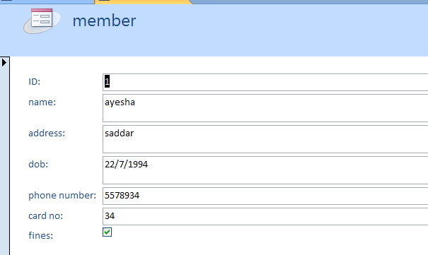

MAIN FORM

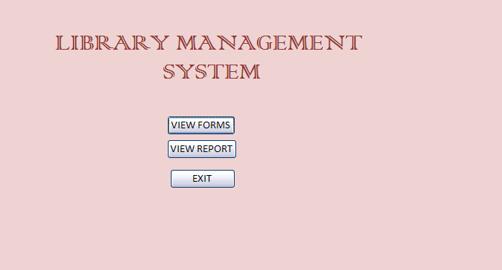

SUB FORM TO OPEN FORMS

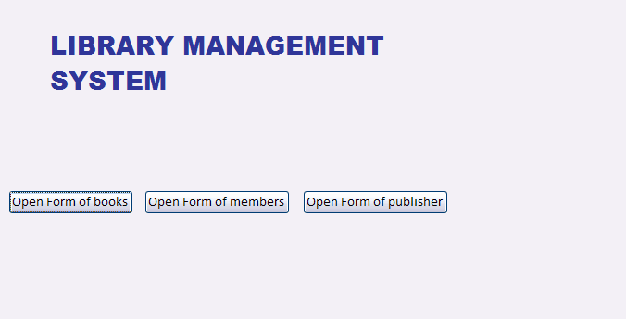

**Reports**

Reports are what you use to summarize and present data in the tables. A report usually answers a specific question, such as "How much money did we receive from each customer this year?" or "What cities are our customers located in?" Each report can be formatted to present the information in the most readable way possible.

A report can be run at any time, and will always reflect the current data in the database. Reports are generally formatted to be printed out, but they can also be viewed on the screen, exported to another program, or sent as e-mail message.there are three reports

SUB FORM TO OPEN REPORTS

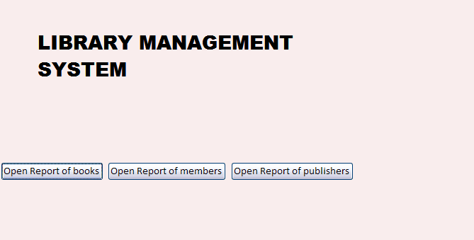

.

REPORT OF BOOK

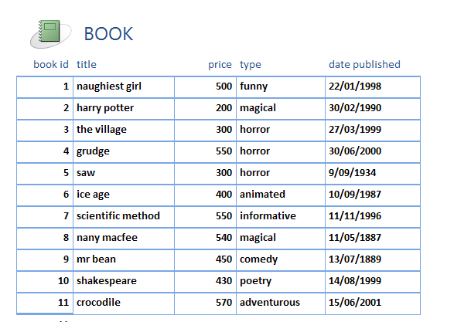

REPORT OF PUBLISHER

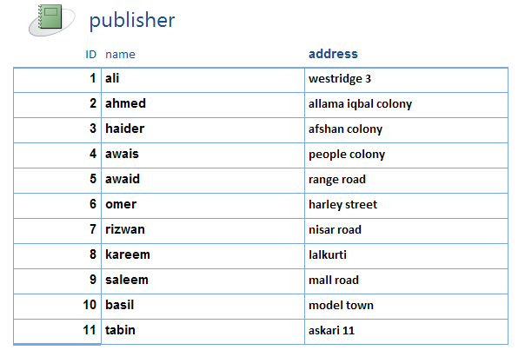

REPORT OF MEMBER

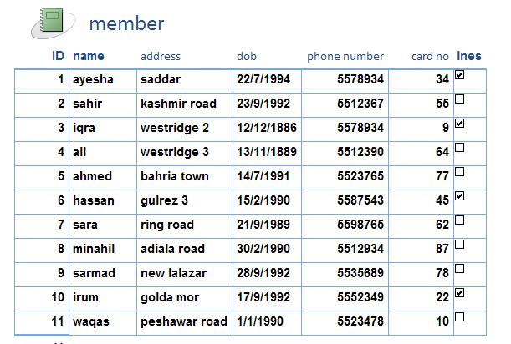

**QUERIES**

Queries are the real workhorses in a database, and can perform many different functions. Their most common function is to retrieve specific data from the tables. The data you want to see is usually spread across several tables, and queries allow you to view it in a single datasheet. Also, since you usually don't want to see all the records at once, queries let you add criteria to "filter" the data down to just the records you want. Queries often serve as the record source for forms and reports.

Certain queries are "updateable," meaning you can edit the data in the underlying tables via the query datasheet. If you are working in an updateable query, remember that your changes are actually being made in the tables, not just in the query datasheet.

Queries come in two basic varieties: select queries and action queries. A select query simply retrieves the data and makes it available for use. You can view the results of the query on the screen, print it out, or copy it to the clipboard. Or, you can use the output of the query as the record source for a form or report.

An action query, as the name implies, performs a task with the data. Action queries can be used to create new tables, add data to existing tables, update data, or delete data.there are three queries

QUERY NO 1

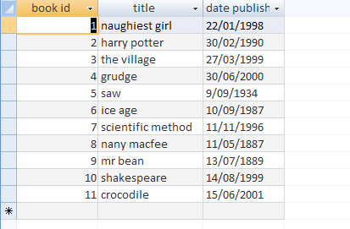

QUERY NO 2

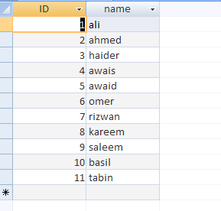

QUERY NO 3

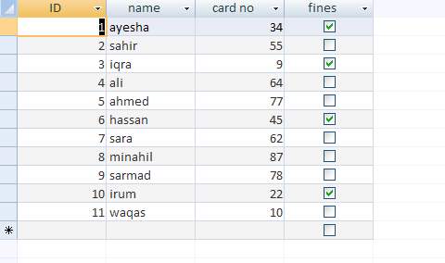

RELATIONSHIPS

